Flynn’s website

portfollio



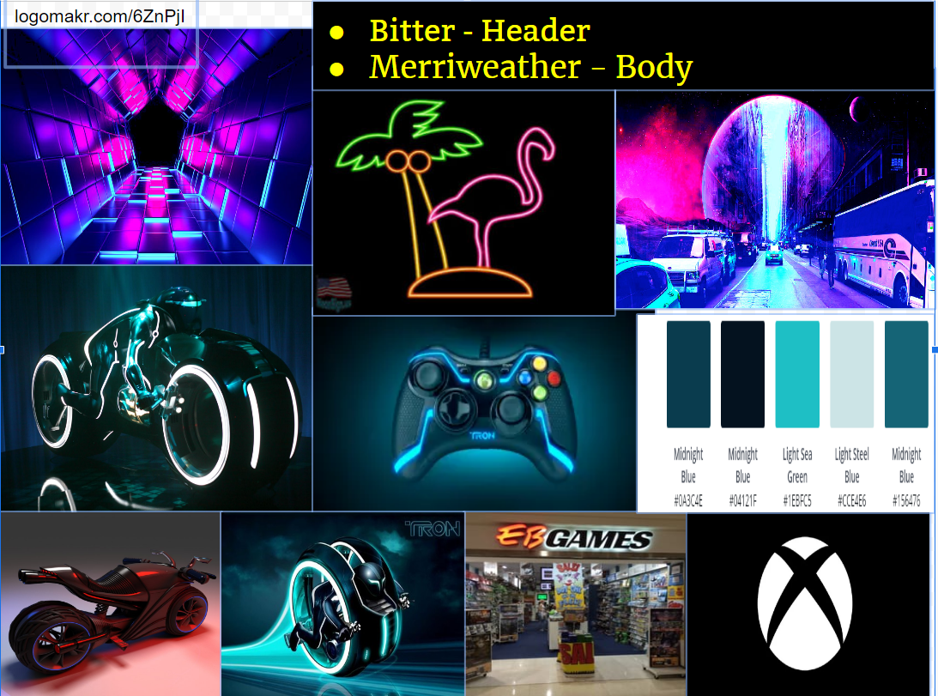

Design brief

Flynn’s Arcade is a video game arcade owned and operated by Kevin Flynn. It is a multi-story establishment, with numerous assembled arcade games on the ground floor and office space on the floor above. The upper rooms have been furnished to serve as both a work space and accommodation. Flynn’s Arcade has been slowly losing money as the trend for accessing video games has moved away from social

Video game arcades to at home and game consoles such as the Atari .Commodore. Flynn wants to

Reposition his business as a venue for selling new games and trading used games. Flynn wants you to design and

Create ‘alpha phase’ website that communicates his new business model.

Area of investigation

Wix is an easy drag and drop creation with hundreds of templates and great tools. Wix lets you build and sell through your site. Beginner-

Friendly and scalable, wix is suitable for anything from personal online portfolios to small business websites.



Weebly is one of the best and well known all in one website it has drag and drop design tools and great functionality and bundles. Weebly is a great website because builders on the market offer unparalleled ease of use and a wide array of innovative features through an extremely efficient user interface. They should provide a better way to purchase email accounts but other than that, Weebly hits the spot.

Kevin Flynn is a great computer programmer whom, in 1982 created some of the best video games for ENCOM which included space paranoids, matrix blaster, vice squad, and light cycles. AS he developed his games, the code he wrote was stolen by fellow ENCOM programmer Ed Dillinge.

Flynn’s hometown is Paramus, New Jersey, where he was born in 1949. Flynn got his doctorate from Caltech in 1980 and got recruited by ENCOM shortly afterwards. As an upcoming young programmer, Flynn began developing new video games in secret, among which included space Paranoids, vice squad, matrix blaster, and light cycles.